Ex1

3 use <make> system will find makefile file auto in current dir

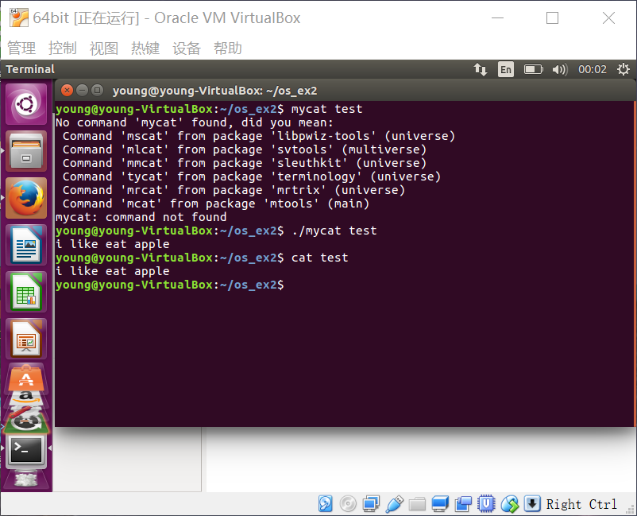

Has the same effect with <cat> command

4.use redirection “>” command

5. 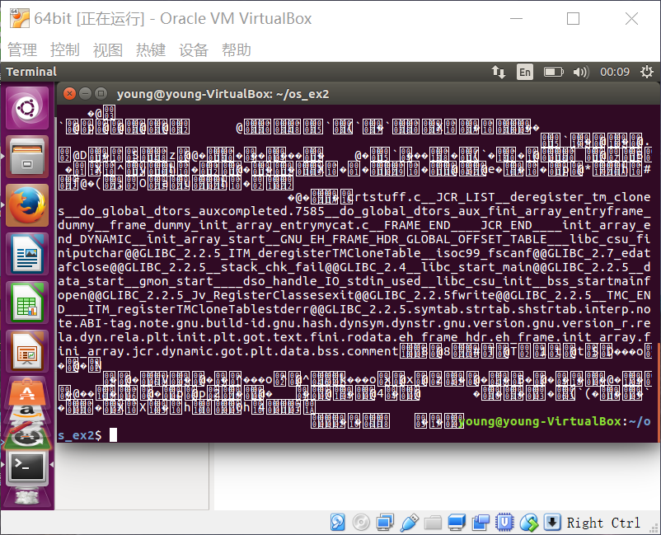

We got unknow information because the not suitable format translation.

Ex2

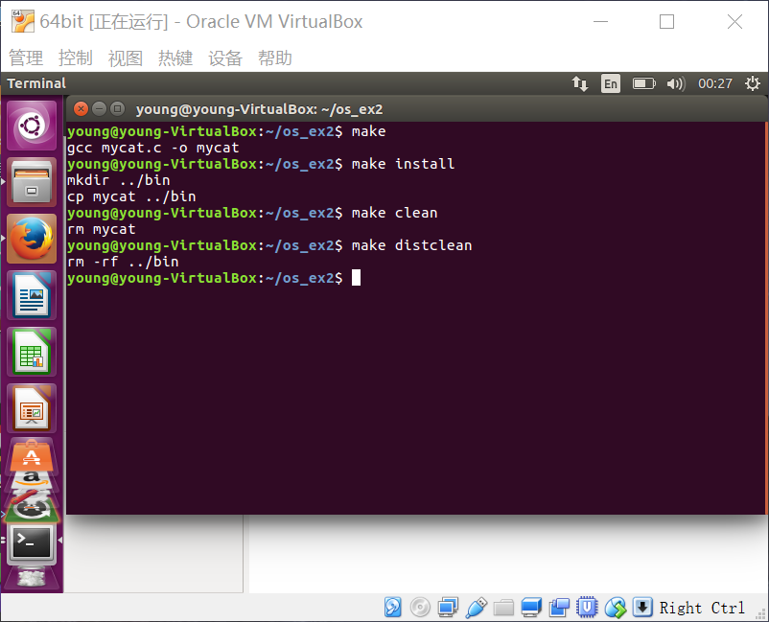

Attention to how to execute make file

Ex3

1. Yes it works. text file is welcome

2.

3.<diff> return nothing is two files are equal. Return message if they are different.

Ex4 ？

Haven’t got what to do…

Ex5

Cat >

Cat >>

Ex6

1 cp -rf

2 rm -rf

3 mv backup origin

Ex7

1. Ls -ali
2. Umask is the method to set user permissions
3. 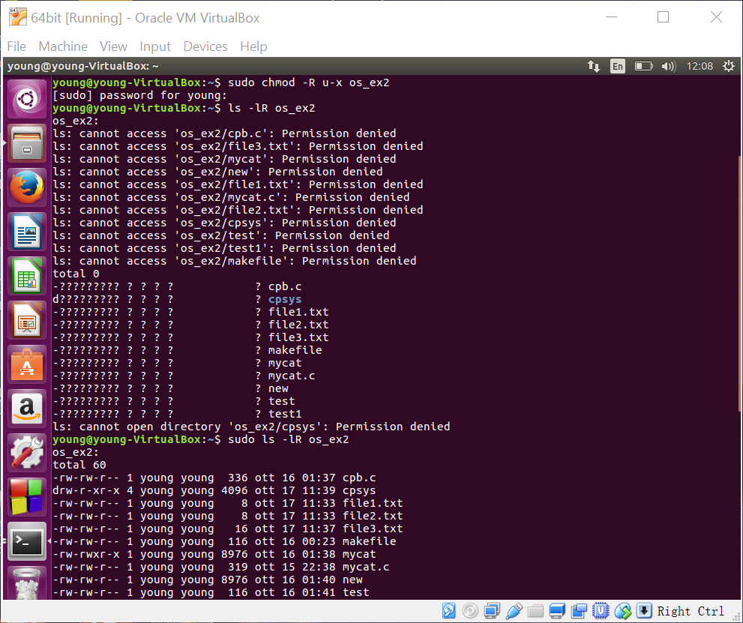

Chmod -R u+x

The execute permission for a file is to access it. If I delete the x permission we will see ??? like figure above.